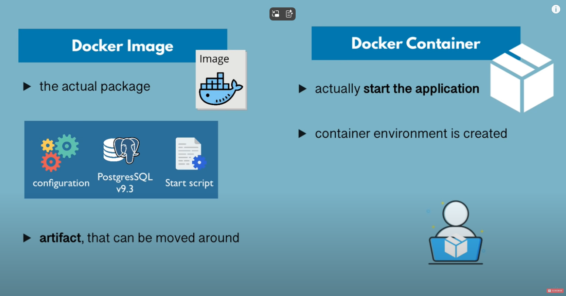

If image is not running its an artifact and it does it is a docker container

Docker and vm are both vurtualization tools.

Difference between Docker and VM

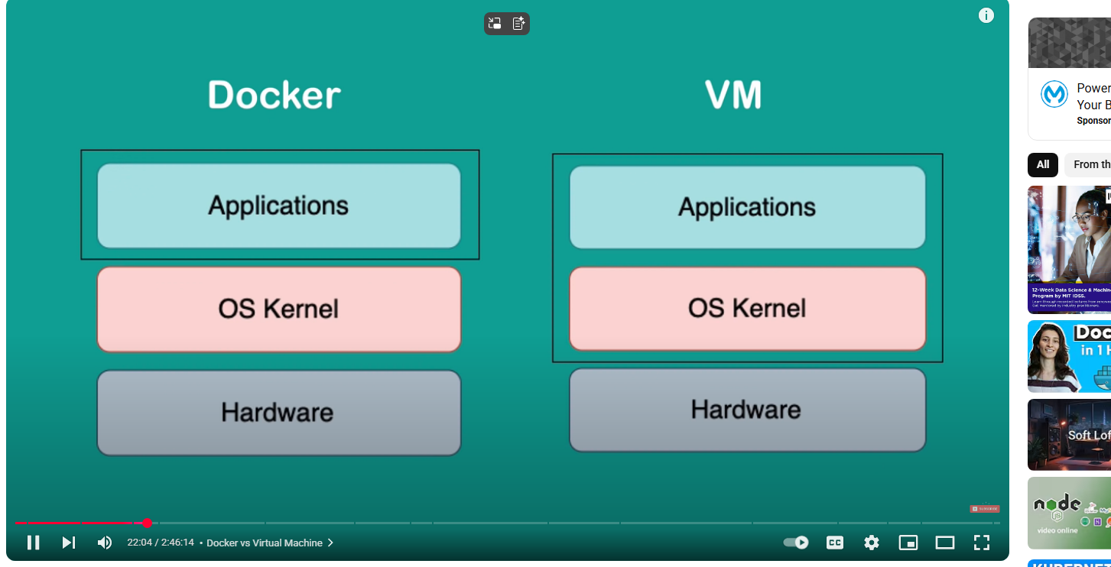

Docker virtualizes the application layer while VM has the OS virtuliazed that is application and OS kernel layer

VS of any OC can run on any host while docker cannot do that.